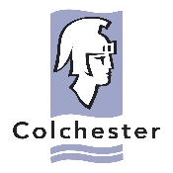
PUBLIC CONSULTATION RESPONSE FORM
Proposed Conservation Area for North Station Road and Environs

Monday 16^{h} April 2018 – Sunday 27th May 2018

Your name: [please add detail]

Your address with post code: [please add detail]

Q1: Do you support the principle of designating the area as a conservation area?

NO
YES

Please explain why if you wish..

Q2: Do you support the principle of restricting permitted development rights?

NO
YES
Please explain why if you wish..

YES
NO

Q3: Do you wish to suggest making alterations to the proposed boundary?
If YES please describe the alteration/s you wish to suggest and the reason/s

Q4: If you wish to make specific comment/s on any part of the Appraisal and Management Proposals document please do so below. These will be considered fully and may influence alteration to and modification of the final document in the event that formal Conservation Area status [Designation] is agreed by the Council’s Local Plan Committee

[please add detail]

