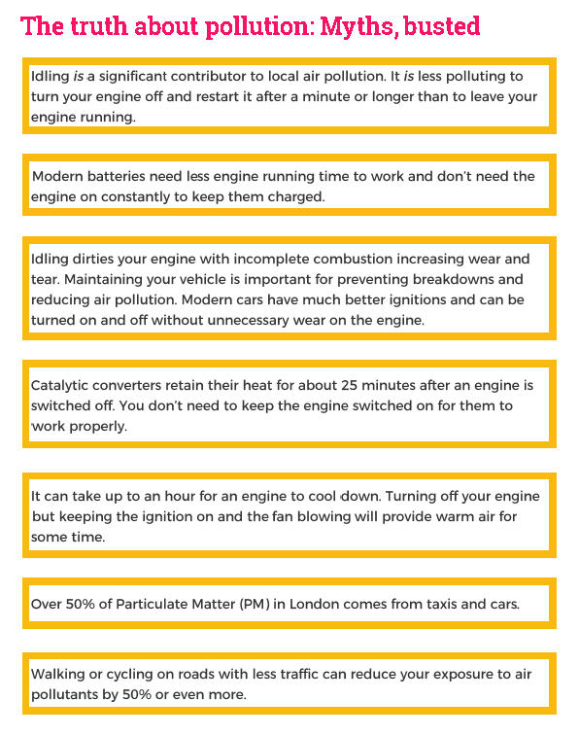

These myth busters come from initial No Idling Campaigns undertaken by TfL.

When developing the campaign TfL undertook some testing and research at Millbrook Proving Ground; this showed that vehicle engines may be restarted repeatedly many times over without a discernible effect on the performance of the vehicle's battery. The vehicles tested were able to withstand repeatedly being switched on and off over a hundred times in an hour with no loss of performance observed. This level of activity would far exceed real-life scenarios