Public notice
Highways Act 1980 Part VIIA
Notice of Application for permission under Section 115E Highways Act 1980
Colchester Borough Council has received an application for permission under Section115E of the Highways Act 1980 to place Barriers, tables and chairs [Patio heaters] at the ‘Front of the [Business] on [Road], Colchester as shown by a red outline mark on the plan below.
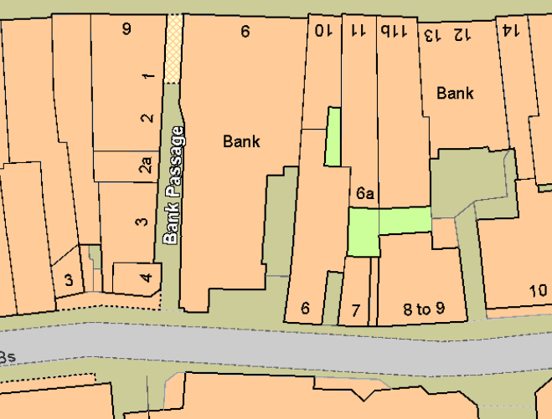
Any person who wishes to make representation in respect of this application should send their representations to Licensing.team@colchester.gov.uk by XX XXXX 20XX. If making representations by post please send them to Licensing, Food and Safety at Colchester Borough Council, Rowan House, Sheepen Road, Colchester, Essex CO3 3WG

Colchester Borough Council Dated

