Public notice
Business and Planning Act 2020 s.2
Highways Act 1980 Part VIIA
Notice of Application for permission under Section 115E Highways Act 1980
Colchester Borough Council has received an application for permission under Section 2 of the Business ad Planning act and Section115E of the Highways Act 1980 to place Barriers, tables and chairs at the Front of XXXXX, XXXX, Colchester COX XXX, as shown by a red chevron outline mark on the plan below.
Example please input your plan here.
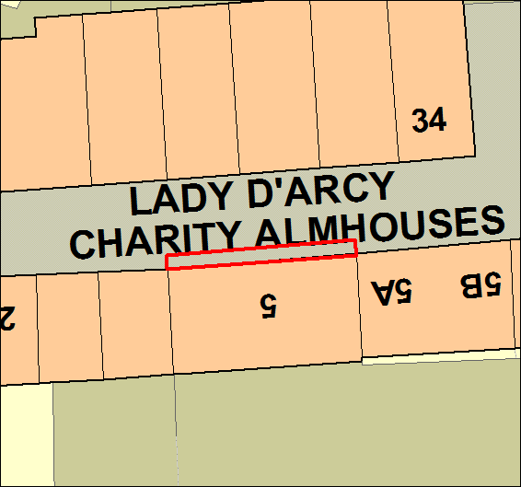
Any person who wishes to make representation in respect of this application should send their representations to Licensing.team@colchester.gov.uk by XX XX 2020 last date for representations being the date 5 working days after the date the application is submitted to the local authority (excluding public holidays)).
If making representations by post please send them to Licensing, Food and Safety at Colchester Borough Council, Rowan House, Sheepen Road, Colchester, Essex CO3 3WG
last date for representations being the date 5 working days after the date the application is submitted to the local authority (excluding public holidays))
Colchester Borough Council Dated XXXXXX

